Median Wages by Sector and Occupation in Bangladesh (2022)

Introduction
This brief presents an analysis of median monthly wages across sectors and occupations in Bangladesh using data from the 2022 Labor Force Survey. The objective is to assess wage differentials across the labor market and understand how sectoral and occupational structures intersect to shape earnings. The analysis is conducted using both unweighted and population-weighted estimates to distinguish between raw survey trends and population-level inferences.
In addition to wage data, we use employment matrix information to contextualize wage disparities in terms of the size and structure of the labor force. Together, these insights help identify areas of vulnerability and potential policy entry points for improving labor market outcomes.

Unweighted Median Wages
Unweighted medians reflect raw differences in wages across observed survey respondents, without adjusting for sampling design. These results provide a first-order view of wage dispersion and sector-occupation dynamics.
Wages by Sector
Unweighted median wages vary widely by sector. Finance, insurance, and real estate report the highest median wage (BDT 6,250), followed by public administration (BDT 5,500) and education (BDT 4,950). In contrast, agriculture (BDT 2,000), accommodation and food services (BDT 2,000), and other services (BDT 1,750) report the lowest median earnings.
These patterns align with the degree of formality, skill intensity, and capital investment across sectors. Formal and capital-intensive sectors tend to offer better pay, while labor-intensive and informal sectors lag behind.
Wages by Occupation
Managers (BDT 6,539), legislators (BDT 6,250), and engineering professionals (BDT 5,500) earn the highest wages among occupations. At the lower end, agricultural workers (BDT 2,000), personal service workers (BDT 2,025), and sales workers (BDT 2,250) reflect the realities of low-skill, informal employment. The wage premium for high-skilled occupations reinforces the role of education, credentials, and labor market signaling in wage determination.
Wages by Sector × Occupation
Cross-tabulations show that wage dispersion is not only sectoral but also occupational within sectors. In finance, health, and education, wage variation across occupations is substantial, reflecting hierarchical structures. In contrast, sectors like agriculture and accommodation exhibit relatively uniform wages across occupational categories, suggesting flatter organizational structures.
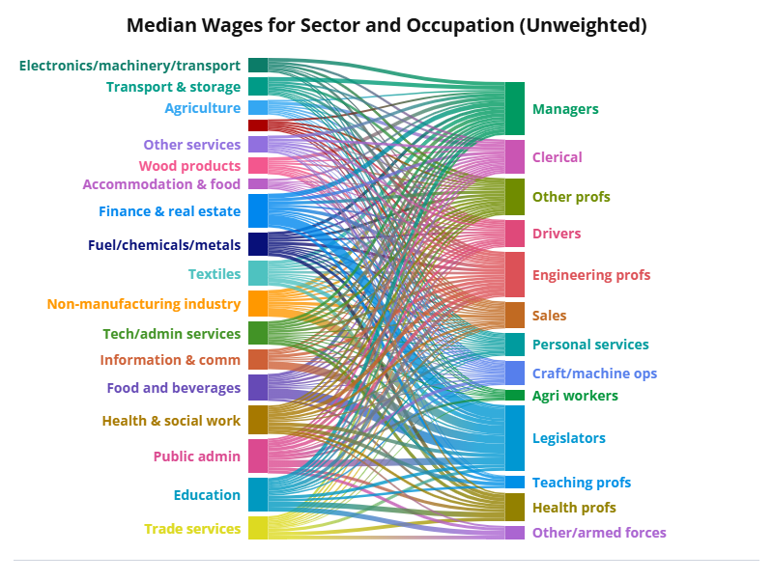
The width of each bar on either side reflects the (unweighted) median wages within that sector or occupation group. Thicker flows between bars indicate stronger wage-linked relationships between specific sectors and occupations. To explore patterns interactively—such as which occupations dominate wage flows within each sector—click the chart or visit the linked version online. You can then highlight individual categories to better understand how wage structures decompose across the labor market.

Weighted Median Wages
Weighted estimates adjust for sample design and population distribution, offering a nationally representative view of the wage structure.
Wages by Sector (Weighted)
The overall pattern remains consistent with unweighted results. Finance, insurance, and real estate (BDT 10,058), public administration (BDT 8,352), and education (BDT 7,220) continue to lead. Agriculture (BDT 3,002), personal services (BDT 2,200), and other services (BDT 1,800) remain at the lower end. While rank orderings are similar, weighted medians tend to compress extreme values, offering a more tempered estimate of wage gaps.
Wages by Occupation (Weighted)
Legislators (BDT 19,175), managers (BDT 10,826), and health professionals (BDT 9,295) continue to dominate the upper wage spectrum. Agricultural workers (BDT 2,250) and sales workers (BDT 2,375) remain among the lowest-paid. The occupational wage hierarchy is more sharply defined in the weighted results, indicating more persistent structural disparities.
Wages by Sector × Occupation (Weighted)
Sector-occupation intersections remain informative. For example, public sector occupations command higher wages across the board, particularly for managerial and professional categories. Manufacturing, trade, and agriculture exhibit more uniform and lower wage distributions, reinforcing the dual structure of the Bangladeshi labor market.
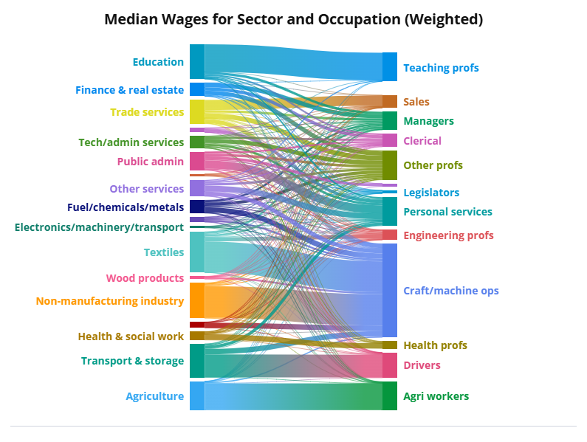
This chart visualizes the flow of population-weighted median wages across sectors and occupations. The width of each bar reflects the total share—not just counts—contributed by each category. Compared to the unweighted version, this chart gives greater prominence to high-employment, high-wage combinations (e.g., teaching professionals in education or craft workers in manufacturing), while down-weighting sparsely populated roles with high wages (e.g., legislators).
To explore interactions between sectors and occupations, click on the chart or view the interactive version online. Highlighting a category allows you to trace how median wage earnings are distributed across the labor force. This helps distinguish between high-paying but niche roles and occupations that matter more in aggregate income terms.

Employment Context
Employment matrix data underscore the importance of contextualizing wage analysis. Agriculture employs the largest share of the labor force, but is concentrated in low-wage occupations—primarily agricultural workers and personal service roles. In contrast, high-wage occupations (e.g., managers, engineers) are concentrated in relatively smaller, formal sectors such as finance, health, and public administration.
In the weighted matrix, nearly 40% of total employment is concentrated in just four sector-occupation pairs: agricultural workers in agriculture, sales workers in trade, personal service workers in accommodation, and craft/machine operators in manufacturing. These combinations also correspond to the lower end of the wage distribution, suggesting a strong overlap between employment concentration and earnings vulnerability.

Conclusion and Policy Implications
Analyzing wages by sector, occupation, and their intersection reveals deep segmentation within Bangladesh’s labor market. The findings highlight three critical insights:
- Formal, capital-intensive sectors pay better wages, but employ a smaller share of the workforce.
- Low-wage sectors dominate employment, particularly for informal or low-skilled workers.
- Occupational skill level drives wage variation, even within the same sector.
These dynamics reinforce the need for targeted labor market interventions. Policies that promote formalization, skill upgrading, and sectoral mobility—particularly in agriculture, trade, and services—could improve earnings potential and reduce inequality. Moreover, combining wage and employment data allows for better identification of high-risk labor market segments and enhances the targeting of active labor market policies.

